**RAJSHAHI UNIVERSITY OF ENGINEERING**

**& TECHNOLOGY**

DEPARTMENT OF ELECTRICAL & COMPUTER ENGINEERING

COURSE N0: ECE - 2214

COURSE TITLE: NUMERICAL TECHNIQUES SESSIONAL

|  |  |
| --- | --- |
| **SUBMITTED BY:**  **NAME:MD SHAHARIAR HASAN RONOK**  **ROLL: 1710046**  **CLASS: 2nd YEAR, EVEN SEMESTER**  **SESSION: 2017-2018**  **DATE OF SUBMISSION:** | **SUBMITTED TO:**  **NAME: Prof. Dr. Md. Shamim Anower**  **DEPARTMENT OF ELECTRICAL & COMPUTER ENGINEERING**  **RAJSHAHI UNIVERSITY OF ENGINEERING & TECHNOLOGY,RUET** |

**ACKNOWLADGEMENT**

***THANK YOU SO MUCH MATHWORK FOR***

***GIVING US THE PERMISSION TO WORK IN***

***YOUR WORLD KNOWN SOFTWARE “MATLAB”.***

***WE ARE VERY MUCH GREATFUL TO YOU.***

**Familiarization of MATLAB and its build in function**

**1.1 Introduction:** The name MATLAB stands for MATrix LABoratory. MATLAB has many advantages compared to conventional computer languages (e.g., C, FORTRAN) for solving technical problems. MATLAB is an interactive system whose basic data element is an array that does not require dimensioning. It has powerful built-in routines that enable a very wide variety of computations. It also has easy to use graphics commands that make the visualization of results immediately available. Specific applications are collected in packages referred to as toolbox. There are toolboxes for signal processing, symbolic computation, control theory, simulation, optimization, and other fields.

When starting MATLAB, a special window called the MATLAB desktop appears. The desktop is a window that contains other windows. The major tools within or accessible from the desktop are:  
1.The Command Window 2.The Command History 3.The Workspace 4.The Current Directory  
5.The Help Browser 6.The Start button

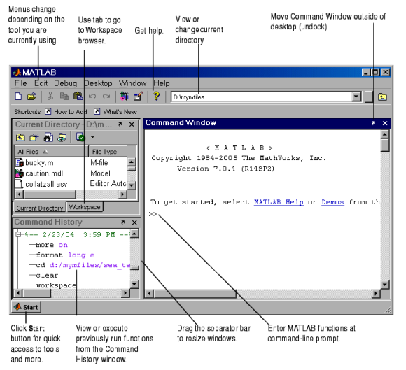

Figure 1.1: The graphical interface to the MATLAB workspace

**1.2 Using MATLAB as a calculator:** Suppose I want to calculate the expression, 1 + 2 *\** 3. You type it at the prompt command (>>) as follows,  
>> 1+2*3  
Ans =7

Another example:  
>> x = 1+2*3

x=7 will result in x being given the value 1 + 2*\** 3 = 7. This variable name can always  
be used to refer to the results of the previous computations. Therefore, computing 4*x* will  
result in  
>> 4*x

Ans=28.0000

**1.3 Creating MATLAB variables:** The syntax of variable assignment is -- variable name = a value  
For example,  
>> x = expression  
where expression is a combination of numerical values, mathematical operators, variables, and function calls. On other words, expression can involve:  
*1.*manual entry *2.*built-in functions *3.*user-deflned functions

**1.4 Controlling the appearance of floating point number:** MATLAB by default displays only 4 decimals in the result of the calculations, for example 163*:*6667, as shown in above examples. However, MATLAB does numerical calculations in *double* precision, which is 15 digits. The command format controls how the results of computations are displayed. Here are some examples of the different formats together with the resulting outputs.  
>> format short  
>> x=-163.6667  
If we want to see all 15 digits, we use the command format long  
>> format long  
>> x= -1.636666666666667e+002  
To return to the standard format, enter format short, or simply format. There are several other formats. For more details, see the MATLAB documentation, or type help format.

**1.5 Entering multiple statements per line:** Commas (,) allow multiple statements per line without suppressing output.  
>> a=7; b=cos(a), c=cosh(a)

Ans b=0.6570 & 548.3170

**1.6 Getting help:** To view the online documentation, select or MATLAB Help directly in the Command Window. On the other hand, information about any command is available by typing  
>> help Command  
Note - At this particular time of our study, it is important to emphasize one main point.  
>> help sqrt

**1.7 Mathematical functions:** MATLAB offers many predefined mathematical functions for technical computing which contains a large set of mathematical functions. Typing help elfun and help specfun calls up full lists of *elementary* and *special* functions respectively. There is a long list of mathematical functions that are *built* into MATLAB. These functions are called *built-ins*. Many standard mathematical functions, such as sin(*x*), cos(*x*), tan(*x*), *ex*, *ln*(*x*), are evaluated by the functions sin, cos, tan, exp, and log respectively in MATLAB.

**Examples**  
the value of the expression *y* = *e¡a* sin(*x*) + 10*py*, for *a* = 5, *x* = 2, and  
*y* = 8 is computed by  
>> a = 5; x = 2; y = 8;  
>> y = exp(-a)*sin(x)+10*sqrt(y)

y=28.2904

The subsequent examples are  
>> log(142)

ans=4.9558

To calculate sin(*…=*4) and *e*10, we enter the following commands in MATLAB,  
>> sin(pi/4)

Ans=0.7071

>> exp(10)

ans=2.2026e+004

**1.9 Basic plotting:** MATLAB has an excellent set of graphic tools. Plotting a given data set or the results of computation is possible with very few commands. Trying to understand mathematical equations with graphics is an enjoyable and very efficient way of learning mathematics.

The MATLAB command to plot a graph is plot(x,y). Shown in Figure 2.1.  
>> x = [1 2 3 4 5 6];  
>> y = [3 -1 2 4 5 1];  
>> plot(x,y)

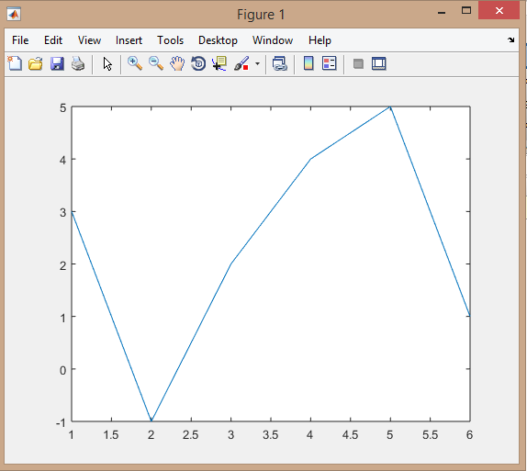

Figure 1.9: Ploting graph of x&y